**UNIVERSITY OF BATANGAS – LIPA CAMPUS**

**COLLEGE OF ENGINEERING AND ARCHITECTURE**

**COMPUTER ENGINEERING**

Analog Values and Sensors

**Experiment #5**

MICROPROCESSOR SYSTEMS

NAME: CASTILLO, JOAQUIN IVERSON M.

TIAMSIM, EDSEL

LASAT, PAULO

STUDENT NUMBER: 2020759

DATE OF SUBMISSION:

May 13, 2023

Engr. Charles Juanillas

PROFESSOR

**Discussion:**

In this next experiment, there will be different sensors to be used like photoresistor, DHT11, and water level sensor. Basic information about different sensors available in the Arduino kit will be discussed.

A photoresistor or light-dependent resistor is composed of photo-conductor material. When light hits this material, the material absorbs the radiation and electrons move from the valance band of the semiconductor to the conduction band. The more electrons in the conduction band of the resistor, the less the resistance of the resistor.

DHT11 sensors are for values on temperature and humidity. These sensors are basic and slow, but are good for basic data logging. It is made of capacitive humidity sensors and a thermistor. For DHT11, it automatically converts the analog signals into digital signal for ease of reading to use for Arduino.

**Objectives:**

At the end of this laboratory exercise, you should be able to:

1. Implement DHT11 and Photoresistor in one program
2. Display the values in LCD

**Equipment and Materials:**

The following equipment and materials are needed in performing this laboratory exercise:

1 – Breadboard

1 – ARDUINO UNO

4 – 47-ohm to 500-ohm ¼W resistor 1 – DHT11 and Photoresistor

1 – 16x2 LCD

Set of Connecting WiresSet of Connecting Wires

**Procedure:**

1. Prepare Arduino, 16x2 LCD, Photoresistor, DHT11, and set of connecting wires.
2. Design your own connection of the different components. Make sure you will create first your own schematic and circuit diagram.
3. Design this experiment with button that will switch the values of sensor to be displayed.
4. The program you will create must read the values of these sensor at the same time.

**Activity Questions:**

1. What is the difference between the DHT11 and photoresistor in terms of:
   * Pin Usage

The DHT11 sensor is equipped with three pins. The first pin is the Data Out, which needs to be connected to the Arduino's Analog IN. The second pin is the VCC, which should be connected to the Arduino's 5V power supply. Finally, there is the GND pin for establishing the ground connection. On the other hand, the Phototransistor has two pins. One of these pins should be connected to the Arduino's Analog IN, while the other pin needs to be connected to the Arduino's 5V power source.

* + Values sent to Arduino

Display the humidity and temperature on the LCD screen. Prior to using the DHT11 sensor with Arduino, it is necessary to install the DHT Sensor library. This library offers the required functionality to interpret the humidity and temperature readings from the sensor. Photoresistors exhibit a decrease in resistance as the intensity of incident light increases. Photoresistors are useful components in circuits that detect light or switch between light and dark conditions. Light-sensitive detectors and light-activated/dark-activated switching circuits can all take advantage of photoresistors.

* + Arduino Compatibility

When connected to an Arduino, the resistance of a photoresistor decreases as the intensity of light falling on its surface increases. This response is reliable and swift. To utilize the DHT11 sensor, it is recommended to use the Arduino IDE software. The DHT library needs to be installed, which can be easily accomplished through the Arduino Library Manager. The DHT11 sensor measures the surrounding air conditions using a capacitive humidity sensor and a thermistor, and then provides a digital signal on the data pin. While it is user-friendly, collecting accurate data requires precise scheduling.

1. Can Arduino handle multiple sensors synchronously?
   * YES

**Procedure:**

1. Prepare Arduino, 16x2 LCD, Photoresistor, DHT11, and set of connecting wires.
2. Design your own connection of the different components. Make sure you will create first your own schematic and circuit diagram.
3. Design this experiment with button that will switch the values of sensor to be displayed.
4. The program you will create must read the values of these sensor at the same time.

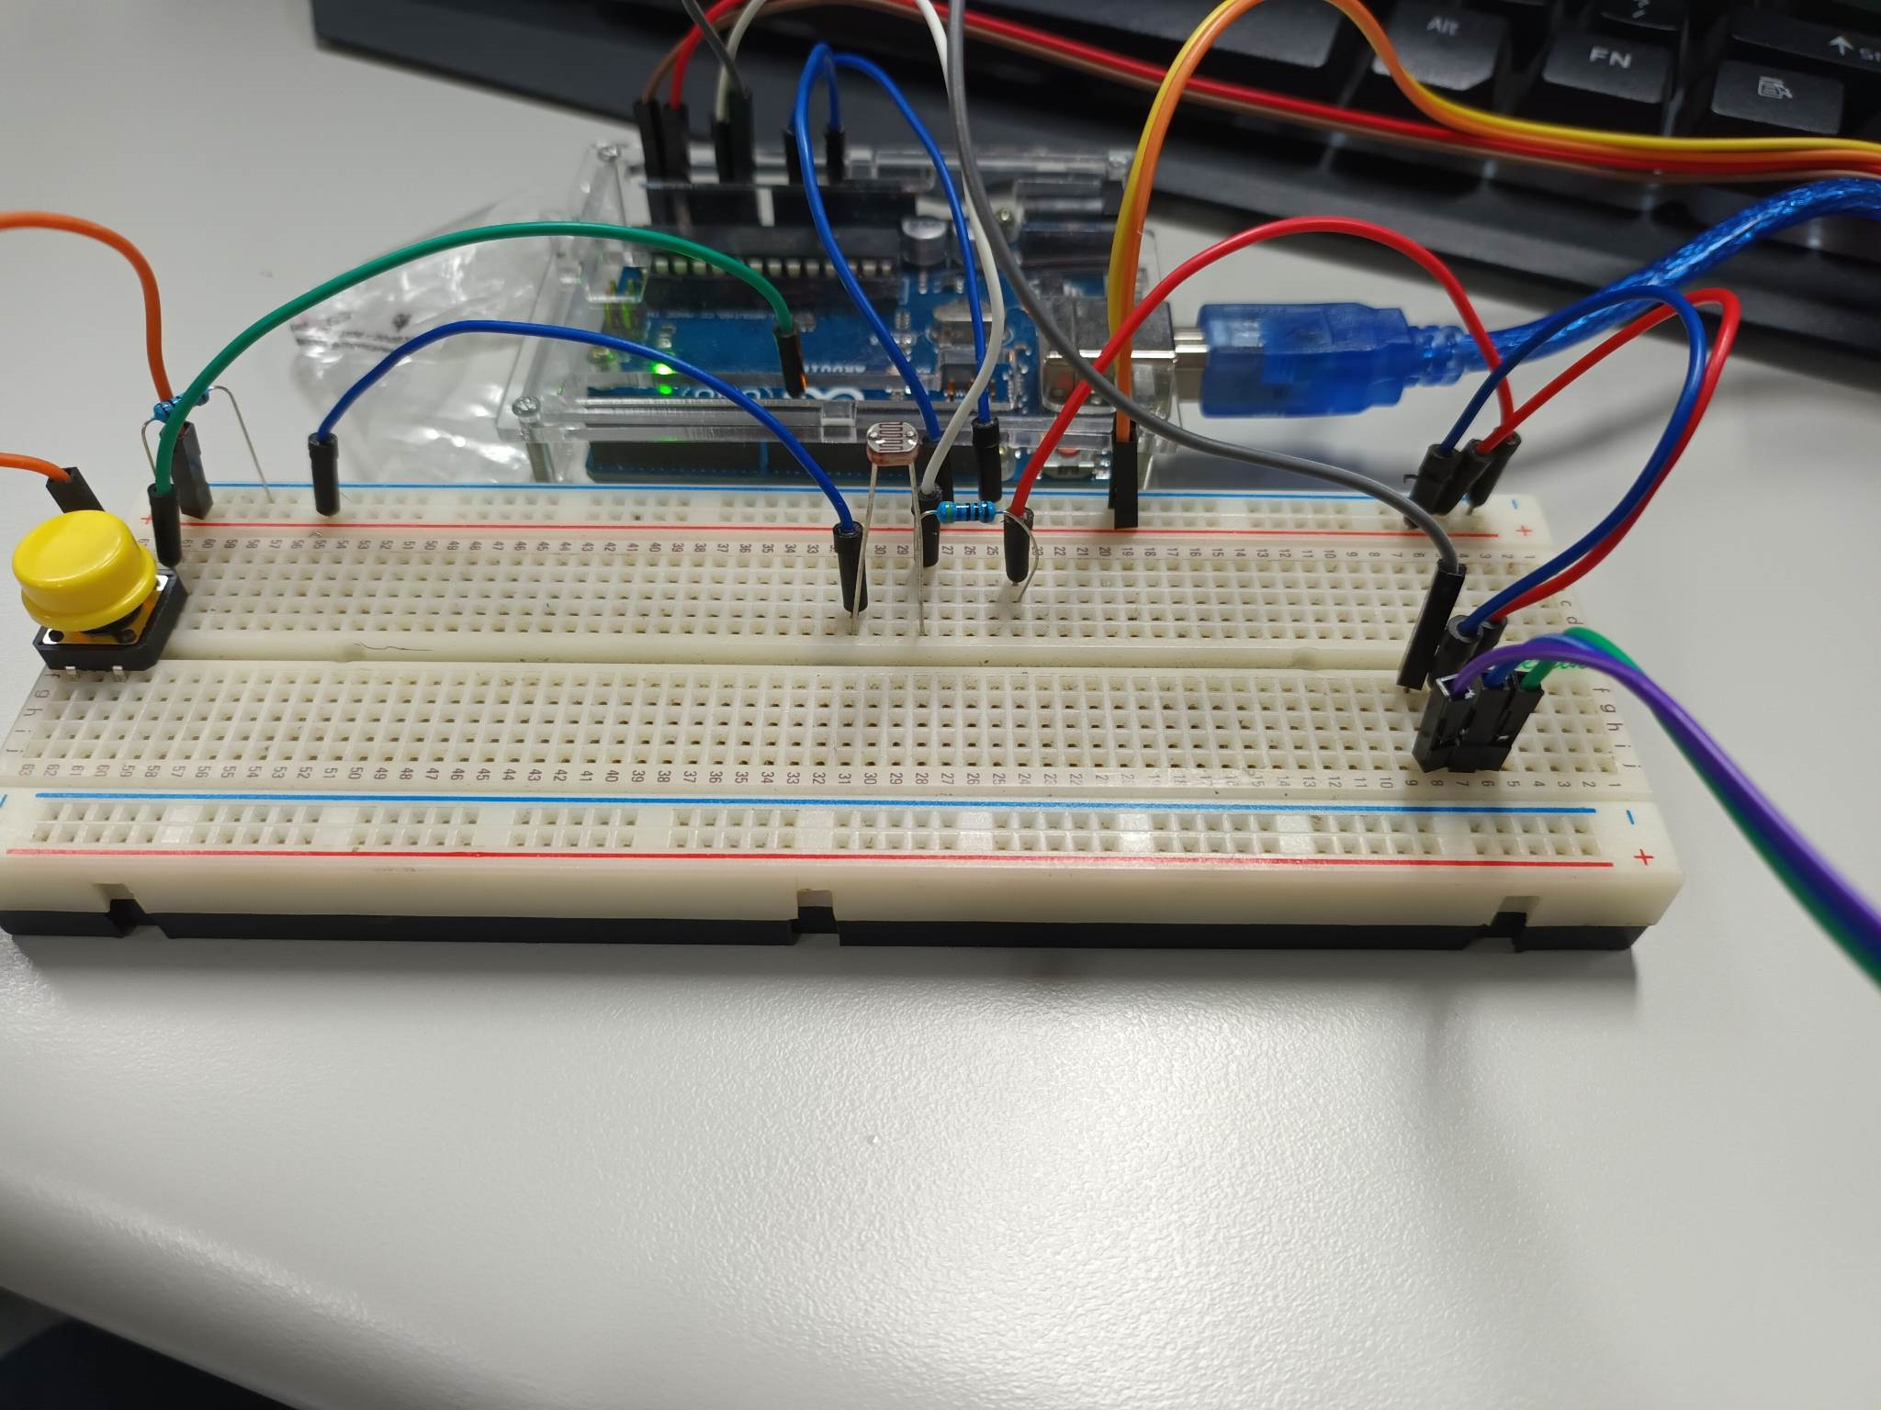

<https://drive.google.com/drive/folders/1TYxkfdhF2R0Rj--9sRBfAmgC81gm1xhB?fbclid=IwAR3f9SAtpRN424DMOR-cMUAUEHbFuS-8qP3Dy_JolVabKbcNDPowObdrbyA>

**Results and Discussion:**

**Conclusion:**

I have learned about the functioning of the DHT11 sensor and the photoresistor through an experiment. The DHT11 sensor is an affordable digital device used for measuring temperature and humidity. It utilizes a capacitive humidity sensor and a thermistor to measure the surrounding air conditions. The sensor produces a digital signal on the data pin, eliminating the need for analog input pins. Although it is easy to use, precise scheduling is required for accurate data collection. On the other hand, the photoresistor's resistance changes when exposed to light. The resistance varies depending on the intensity of the incident light. Higher intensity light results in lower resistance, whereas lower intensity light leads to increased resistance. I also encountered a challenge with the photoresistor, where it becomes difficult to detect light when the resistance is too high. To address this, I decreased the resistance value, simplifying the process of light detection.

REFERENCES:

• https://arduino.cc